23.54: a) 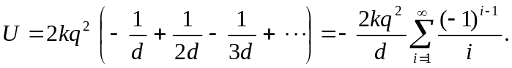

b) 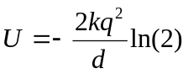

c) The potential energy is the same for the negative ions—the equations are identical if we examine (a).
d) If 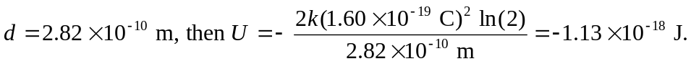

e) The real energy 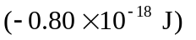is about 70% of that calculated above.

